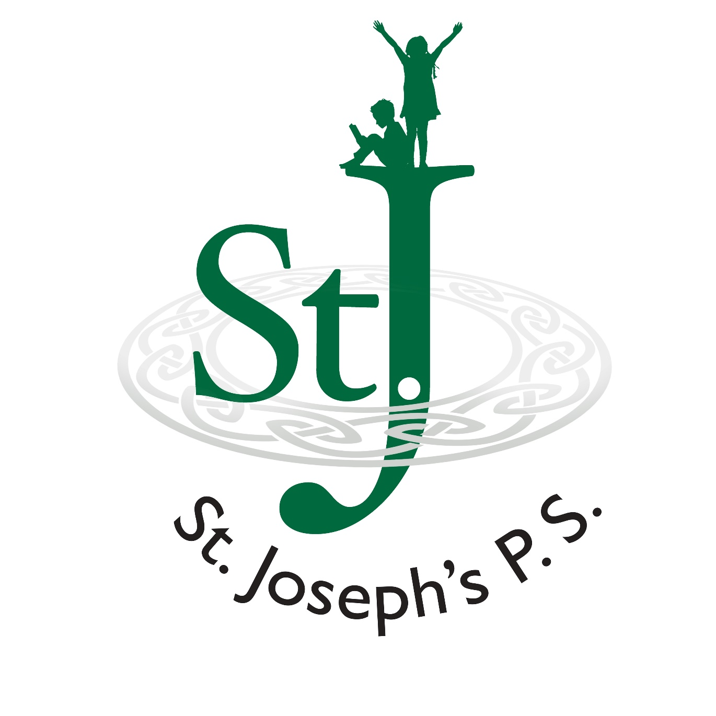
Charging Policy

Basic Principle
The basic principle is that education for pupils in maintained schools should be free of charge if it:
 takes place in schools hours (i.e. the hours when the school is in session not counting the midday break) or
 is outside school hours but is a part of the Northern Ireland Curriculum or statutory religious education.

Activities in School Hours
The governors’ wish the many activities provided during school time to enhance delivery and understanding of the curriculum to continue. The activities may be funded by voluntary contributions from the parents or school budget.
These contributions will be genuinely voluntary and it will be made quite clear to parents that there is
(a) no obligation to contribute
(b) the pupils will not be treated differently according to whether or not their parents have made any contribution in response to the request.
It will be made clear to the parents that these types of activity can only continue if funded by voluntary contributions. Also it will be made equally clear that the activity would not take place if parents were reluctant to support it.
If there is less than 100% response a decision will be made by the Principal whether to pursue the activity. If the activity is to continue, the shortfall in contributions will be met by School Fund.

Residential visits or activities taking place wholly or mainly out of school hours
The governors will allow the full cost of the following to be charged:-
(a) a pupil's travel;
(b) a pupil's board and lodging;
(c) materials, books, instruments and other equipment;
(d) entrance fees to museums, castles, theatres etc.
(e) insurance;
(f) the provision of teaching staff engaged specifically for the purpose of providing the activity, if charged.

Individual/Small Group Music Instrumental Teaching
These activities may take place both during the school day and outside school hours.
The governors will allow a charge to be made for tuition provided individually or to a group in a musical instrument (not vocal tuition) when
a) the tuition is provided by a teacher not currently employed by the school for that purpose
b) the content of the lessons is over and above the requirements of the National Curriculum.
 Instrumental teachers will keep an attendance register.
 All pupils are expected to attend at the time allocated on the timetable. If a pupil is present at school but unable to attend a lesson he/she must inform the instrumental teacher at the earliest opportunity.
 Repeated failure to attend lessons without agreement of the music tutor may result in the withdrawal of the pupil’s entitlement to instrumental tuition that term, without refund
 When a pupil’s progress falls short of expectations the parents will be informed. Failure to make the required progress following this may result in the entitlement to lessons being reviewed at the behest of the music tutor

LOAN OF INSTRUMENTS
 Education Authority/ School of Music etc. owned instruments on loan become the responsibility of the pupil’s parents/guardians. Parents/guardians are therefore strongly recommended to insure instruments for all risks.

CHARGING
 The School will not make a profit from instrumental tuition charges.
 A standard termly charge will be made for each pupil receiving instrumental tuition.
The annual charge for this academic year is £90 and we offer parents the opportunity to pay this fee in three £30 instalments.
There is a further charge per annum for instrument hire this is made by the School of Music Support Service. This is also charged to parents.
There is no charge for instrument hire for those children who are currently in receipt of Free School Meals.
 No child will be charged any more than the actual cost to the school of providing that pupil’s tuition.
 Parents will be notified at the beginning of each individual term for the lessons for that term.
 Should a child be away from school due to sickness, the school will be prepared to discuss a refund in certain circumstances.

A block of Afterschool clubs 4/8 weeks normally costs between £3-£5 per club depending on the number of weeks. At most families will pay £20 for their child to attend clubs Mon-Fri for 8 weeks.
Internet and E-Safety
The school has internet access in every classroom. Any use of the Internet will be strictly in accordance with the school’s Internet Acceptable Use Policy, which has been communicated to and agreed by staff, pupils, governors and parents. Pupils are provided with opportunities to develop knowledge and understanding of e-safety and acceptable online behaviour at a level appropriate to their age and ICT capability.

